Math 4 Honors Name ______________________________

Lesson 6-3: *The Derivative Function* Date ______________________________

**Learning Goals:**

* *I can use the derivative function to compute derivatives.*
* *I can use the formula for the derivative of a quadratic function.*
* *I can use the derivative function to solve problems.*

I. **Definition:** Suppose that *f* is a function that has a derivative *f’(x)* at each point *x* in the domain of *f.*

then the function *f’*: *x → f’(x)* for all *x* in the domain of *f* is called the **derivative function of *f.***

[](http://www.google.com/imgres?hl=en&safe=active&biw=1280&bih=929&tbm=isch&tbnid=Nws9YnZ4YbQcpM:&imgrefurl=http://compasstech.com.au/TNS_Authoring/poly.html&docid=qzgNDPMLLAl4NM&imgurl=http://compasstech.com.au/TNSINTRO/TI-NspireCD/HTML_files/Nspire_logo.jpg&w=913&h=210&ei=nOw4UfGwJvCLyAHf_IHQBw&zoom=1&ved=1t:3588,r:8,s:0,i:103&iact=rc&dur=603&page=1&tbnh=60&tbnw=264&start=0&ndsp=22&tx=110&ty=20)

time! Follow the steps below to investigate the derivative as a function.

1. Open a new document and select 4: Add Lists & Spreadsheet.
2. Name column A, *x*; column B, *f* and column C, *fprime.* Enter the ordered pairs shown below.

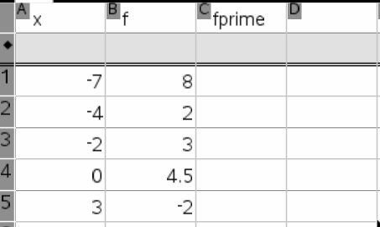

1. Open up a new page and create a scatterplot by choosing 2: Add Graphs 🡪 menu 🡪 3: Graph Entry/Edit 🡪5: Scatterplot. Adjust your window so you can see all 5 points.
2. Go back to your table and perform a cubic regression. Add the curve to your scatterplot by selecting

menu 🡪 3: Graph Entry/Edit 🡪1: Function. Move the up arrow to find the equation f1(x).

1. Draw a tangent line at the point (-7, 8). Have the calculator display the coordinates of the point of tangency. Then have the calculator display the equation of the tangent line. Move the point of tangency so that it is at the point (-7, 8). Record the slope *(round to the nearest integer*) of the tangent line in the table above.
2. Drag the tangent line to the next point & record the slope again. Repeat this process for the remaining 3 points.
3. Enter the slopes into list C of your table.
4. Open up a new page and create a new scatterplot using the *x* and *fprime* lists.

* What type of function does this new graph appear to be?

Perform your regression and add the curve to the scatterplot.

1. What type of function do you *think* *f ’’(x)* would be? What is its degree?

* Repeat steps 4 – 7 to verify your answer *(round the slopes to the nearest 10th*).

Based on this exploration, what happens to the degree each time you take the derivative of a function?

OVER 🡪

Page 2

II. **Theorem: The Derivative of a Quadratic Function:**

If *f(x) = ax2 + bx + c* where *a*, *b* and *c* are real numbers and *a* ≠ 0, then *f’(x) =* 2*ax + b* for all real numbers *x. (*** “x” is the variable.)*



**Proof:**

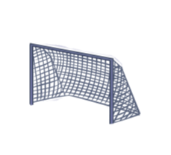

*GOAL! f’(x) =* 2*ax + b*

Page 3

**Example #2:** Consider the quadratic function *f(x) = x*2 *+* 4used in Investigation 2.

1. Find *f’(x)* algebraically, using the algebraic definition of derivative.
2. 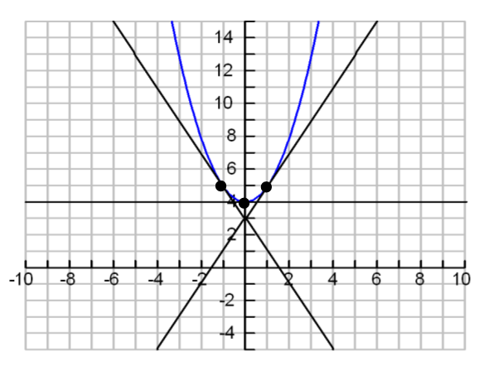Find *f’(x)* graphically. *f*(*x*)
   * + - 1. *f(x) = x*2 *+* 4

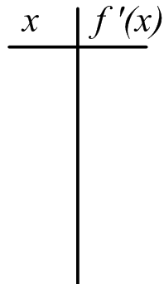

*x*

1. Find *f’(x)* using the new theorem.

OVER 🡪

Page 4

*\*\*\*The theorem for the derivative of a quadratic function can be extended to linear and constant functions.*

If *f(x) = ax2 + bx + c,* then *f’(x) = _____________.*

**Example #3:** Find the derivativeof *f(x) =* 3*x* + 2.

*a = _______ b = _______ c = _______*

*f’(x) = _____________*

**Example #4:** Find the derivativeof *f(x) =* 5.

*a = _______ b = _______ c = _______*

*f’(x) = _____________*

**Example #5:** Verify that the circumference of a circle is the derivative of its area.

Math 4 Honors Name ______________________________

HW: Lesson 6-3: *The Derivative Function* Date _____________________________

**Day 1 Problems:**

1. 



1. 

*Use a ruler to draw 7 tangent lines to the curve . . . .*





**Day 2 Problems:**

**Part A:**





OVER 🡪

** 5.**

 **6.**

**Part B:**

***Notation: In addition to *f’(x),* various notations are used to denote the derivative of *y = f(x).*

The ones most commonly used are *y’* and .  should be thought of as the “derivative of *y* with respect to the variable *x.*”

